Chad Galloway

CST-135

03/30/2018

Mark Smithers

Topic 2 Vending Machine Design Document.

This document contains design, implementation, and usage information for the group project in week two of the class CST-135. The application in which we are designing is a vending machine that contains and dispenses goods such as candy, sodas, and chips.

The abstract base class of Product is a general class that carries all the low-level implementation and fields for products in the vending machine. The Drink class inherits the base class of Product and has no additional fields and contains a set constructors and an overloaded toString() method. The abstract Snack class inherits the base class of Product and contains a set constructors and an overloaded toString() method. The classes Candy, Chips, and Gum all inherit from the Snack class and contain a set of constructors with an overloaded toString() method and no additional fields. The Product class contains methods for getting the value in the private fields as well as methods for changing the fields.

The Dispenser class has an ArrayList to hold the list of products in the vending machine, a method to populate the product list, and a method to display the products in the dispensers list. The method that creates the products in the dispenser tests the constructors of the various subclasses in succession and the method to display the products outputs the results of product creation.

The Main class is a simple driver class that creates a dispenser object and displays the contents of that object.

UML Diagram is provided below for visual representation of the class relationship hierarchy.

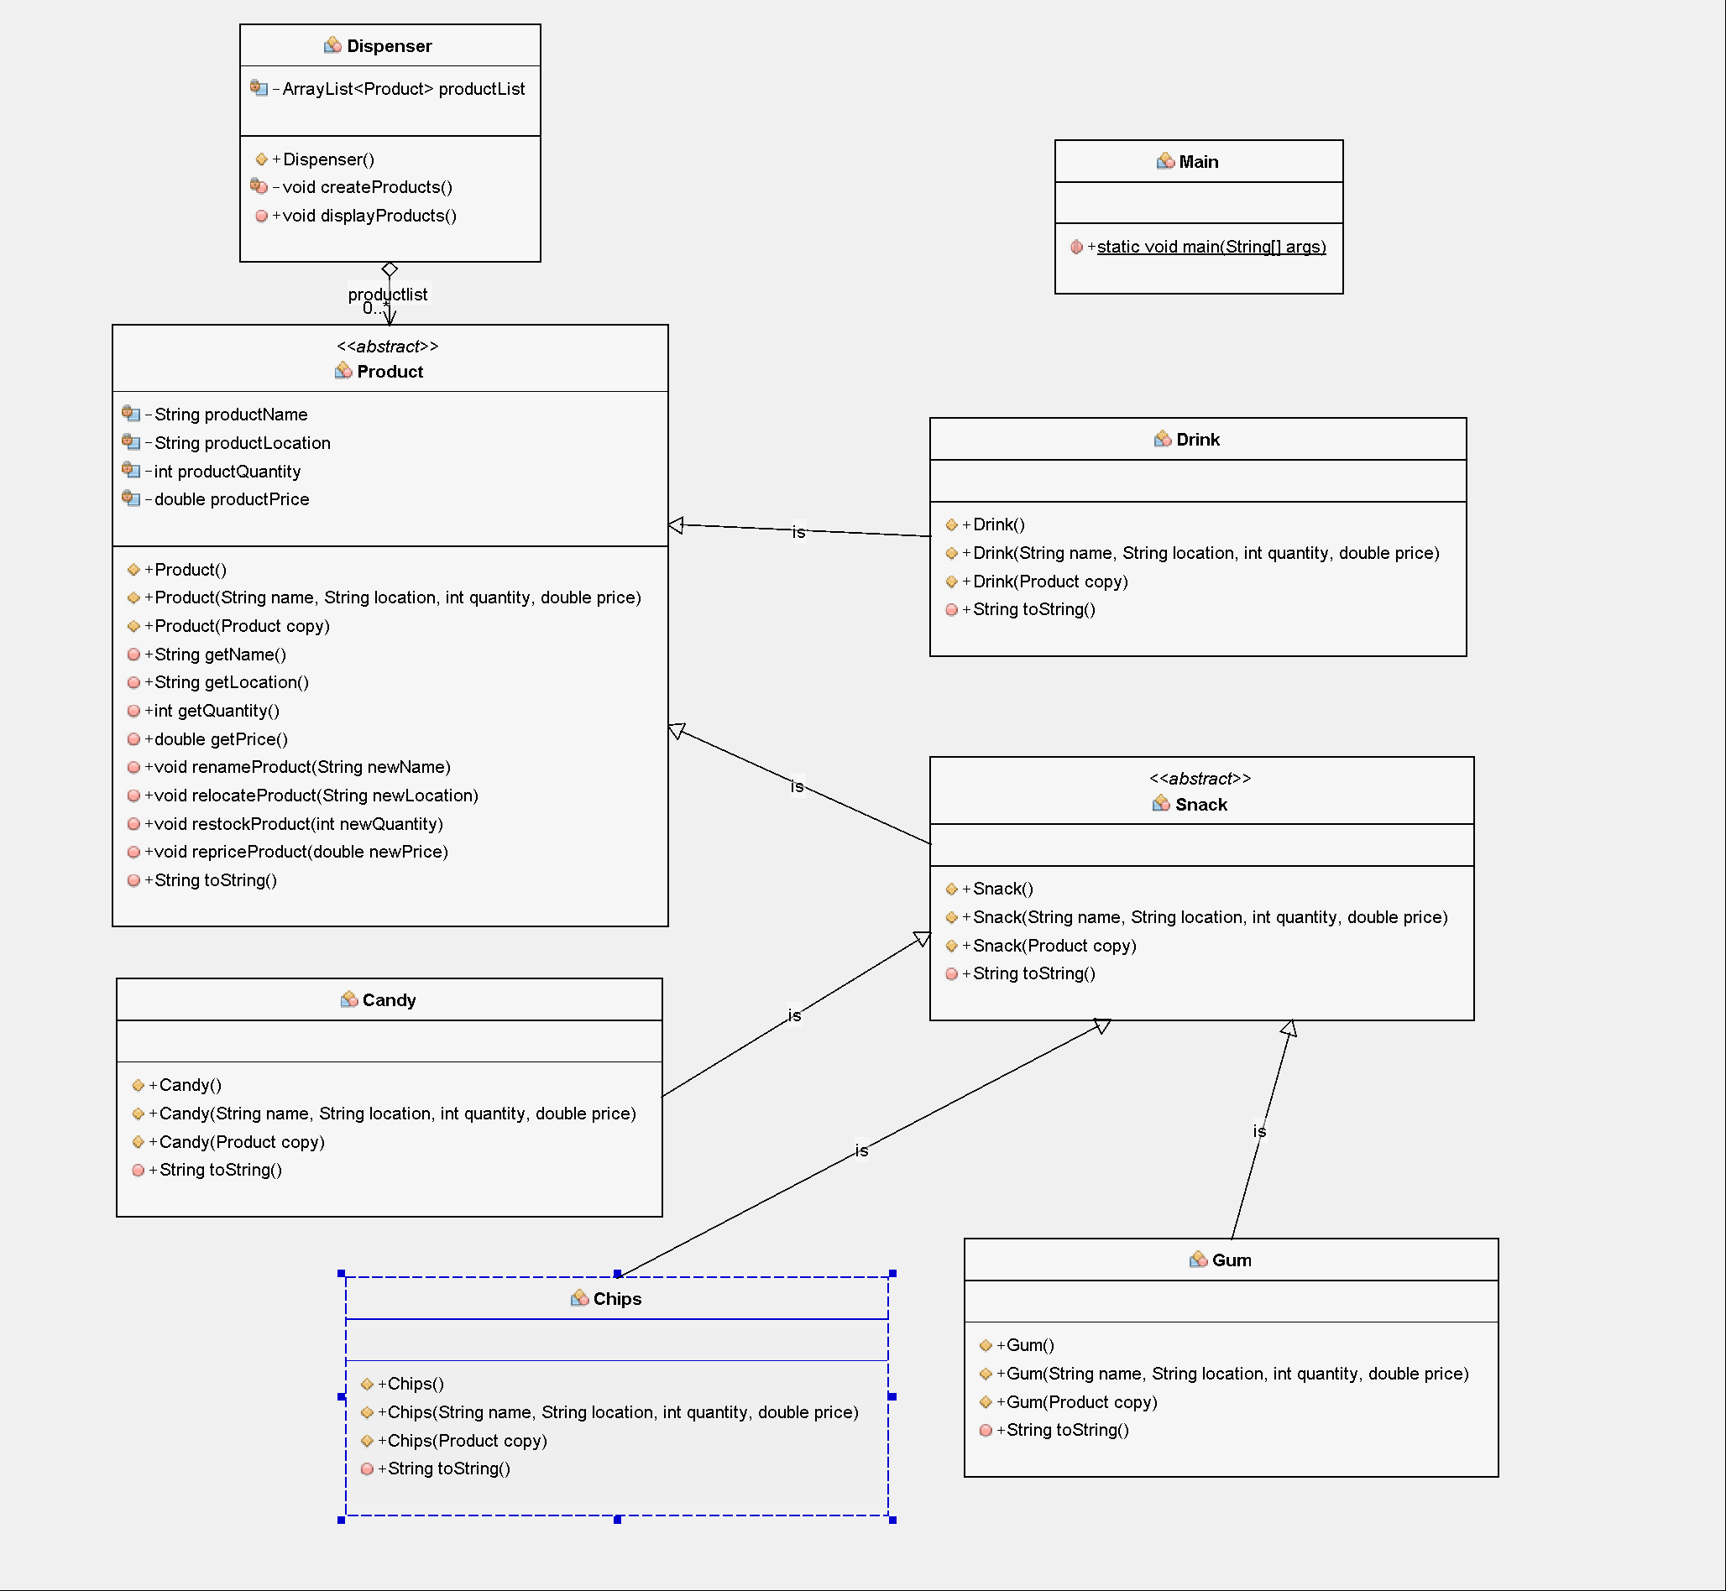

The files provided in the zip file can be extracted to a folder and added to a new project. Running the project after importing the new files will display the results of the product list in the console window.